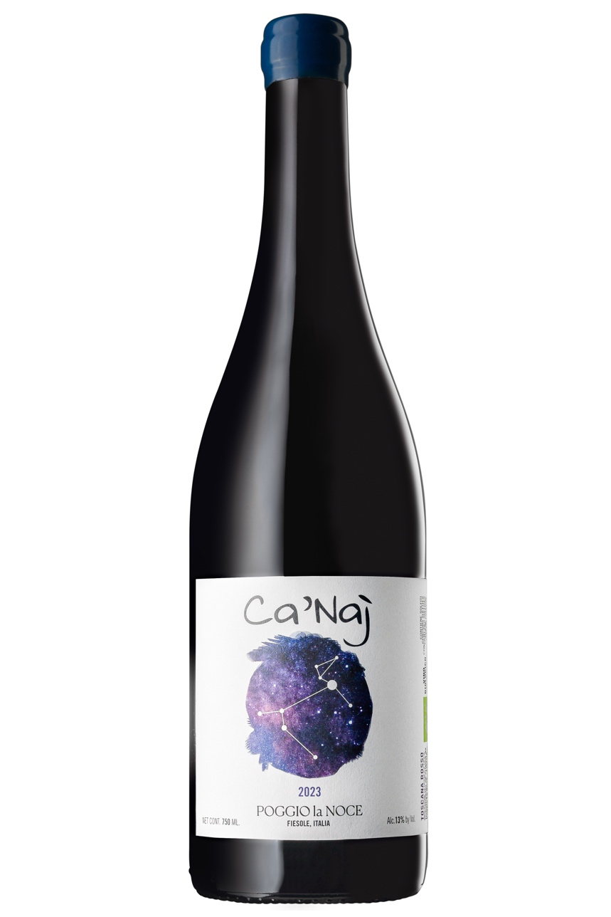

Characteristics of the vineyard | Location of the vineyard “Le Civette”: Fiesole (FI)  Elevation: 250m / 820ft  Size: 2.5 hectares / 6.1 acres  Soil: predominantly calcareous marl with alberese and galestro strata  Orientation: South – South/West  Vineyard density: 5600 plants per hectare  Training system: Guyot  Average age of the vines: 8 years
Appelation | IGT Toscana Rosso
Varietals | 100% Canaiolo
Winemaking and ageing | Yield: 40 Hl/hectare  Time of harvest: second half of September, manual harvest.  Fermentation: after destemming and careful sorting on the selection tables, the grapes are fermented in stainless steel vats with temperature control, using indigenous yeasts.  Ageing: 6 months in large oak.
Bottles produced | 400 bottles
Tasting notes | Ruby red with light shades of purple. Nose of intense red fruit. In the mouth, light structure, with well-integrated tannins, ends with delicate and good persistence.

